# ***List of reports created on the Nuvia Data Team***

*Created by: Cristian Rafael Mendoza Maldonado*

*Data scientist – Nuvia data team – Platform support*

# Lab metric report:

This report contain the number of arches and metrics of the products by center and regions. To use this report you need to update the month of the report you want to created, please first look at the **Nuvia app report.pdf**  on this folder to know to add the information if you are creating a report of a new month after december 2023. Once you make sure to have the updated information of the created and finished orders of the month, please doble click on the **nuvia_app_report.bat** file. It will show you a black screen as in imagen 1.0, please follow the instruccions or look for the **READ_ME.md** file on the same folder.

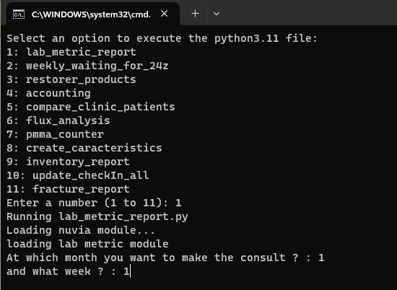

Imagen 1.0 : nuvia_app_report screen, reports selecction.

One you select the 1 for lab metric report and select the month and week of the report as in image 1.0 the creation of the report will begin and it’ll appear on you screen some similar message as in image 1.1, please take in count the part that describe the week and the month for what you are creating the report and in case it´s needed the ***new products to add*** on the app, if a new product it not added yet to this software please contact [cristian@nuviasmiles.com](mailto:cristian@nuviasmiles.com) to solve this issue or look for the .json file yourself.

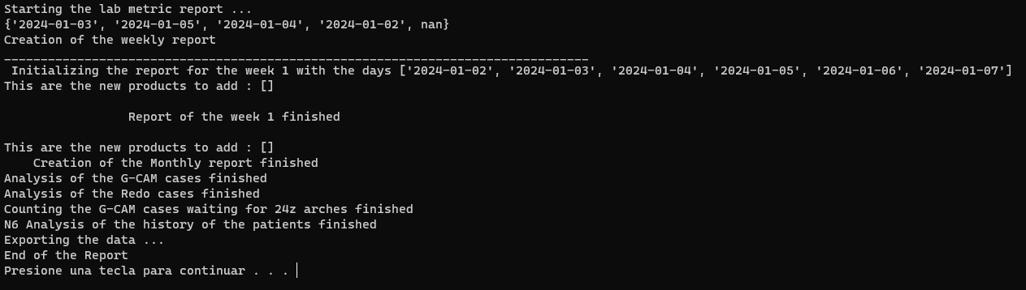

Imagen 1.1 : message while creating lab metric report.

As the result of this part, the software will export 3 excels files, named as :

***“Reported_sheets_{month}.xlsx” ,***

***“Gcam_cases_studied_false_{month}.xlsx” ,***

***“Redo_cases_false_{month}.xlsx”***

Where {month} it´s the number of the selected month for the report. You could find those files on the path **". \nuvia_app_reports\results".** For the Gcam cases file you will find a sheet with the columns below showed on image 1.0.

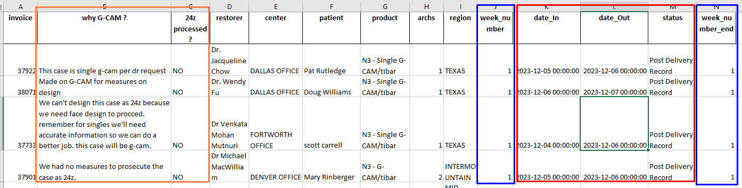

Imagen 1.2: gcam order´s file.

This excel file give you the gcam cases of the month, they were needed for the fullfil of two columns highlighted in orange in the image 1.0, where you need to describe the cause of the G-CAM material selection in the cases and for the single product on the **why G-CAM ?** column. One zirconia arch is producted while the demodenture is processed and it´s part of the demodenture process, if a gcam product it´s selected and this zirconia it´s processing, this material it´s lost and you need to describe it on the ***24z processed?*** Column because this not happend on all the cases.

You will find more information like : invoice, restorer name, center, patient, product name, number of arches, region for a correct description of the cases. Therefor you should take in count the columns under the red box. Those are ***date_in, date_Out*** and ***status*** where you can find the date of creation and delivery of the cases, also the status column hace the name of the stage where the cases it´s in. On the blue boxes you will fine this same information but separated by the number of the week, this week you can find it on the path “.\documentation\ *.md” the you should look for the ***weekYEAR.md*** file for the year of you selection.

For the study of the redo cases you should consult the file named ***“Redo_cases_false_{month}.xlsx”.*** There you will find the listo of the redo orders made on the month of you consult as you can see on imagen 1.1. On the showed columns you will have number of the orden with some important characteristic used for the classification of this products on the production of the month.

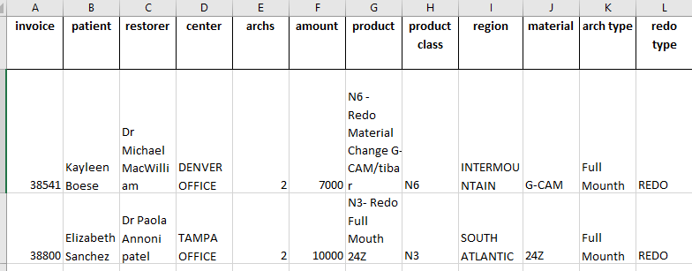

Image 1.3 : First seccion of the columns on the redo cases excel file.

On the second hand if you look further on the columns you should get the section showed on imagen1.2, there you have the information regarded about the delivery of this arches, below it will explained each column in details :

* **diff_hour :** This are the number of hours needed to delivered this cases. It consider the sustraccion of the not productivity time, like weekends and holidays.
* **Delivery_on_time :** This column have the information that confirm if the cases was delivery on time. If it´s empty the cases was not delivery yet or it was not delivered on the standart time.
* **week_number :** This is the number of the week when the cases was created. If it´s empty should mean that the creation of the product was made on that month but it was counted on the previous weekly report. For that it keeps empty.
* **Week_number_end:** This is the number of the week when the case is delivery. If it´s empty means that the cases was not delivery yet.
* **Status:** This column have the name of the stage the cases is currently in. Take in count that the criteria for the count of finished cases it´s exactly that the case is in Post delivery record stage. If not, the cases will not count on future mesurements and the calculation of metrics.
* **CheckIn and CheckOut :** This columns have the exactly date and time information about the creation and the finalization of the cases. Take in count that the checkIn column has the time when the order it´s created and CheckOut has the information of when the cases is finished on the laboratory part, that means, when the lab check out stage it´s approved and the Post delivery cases stage it´s created.
* **Created_on_month and finished_on_month :** This two columns have the information of the cases that are created and finished in the same month of the report. This columns were created to solve the problem of selection of the product that belongs only for the month of the report, because of the weekly report not match exactly with the end of the months.
* **History_status:** this columns have the information about the new casea that were added on the report, if it was a old reported cases that was saved on the path ***“./data/YEAR/Redo_cases_studied.xlsx”***  it should be empty but if it´s not, it will have the **“new”** value on it.

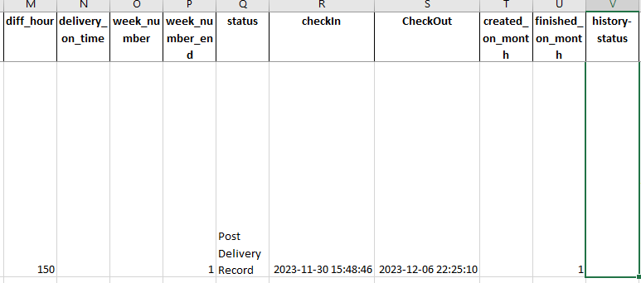

Image 1.4 : second section of columns on redo arches excel file, delivery information about one case.

Finally the last section have the columns that you should fullfil for the creation of the repor, those are : redo cause , responsable pary, redo form. As you can see on image 1.3,

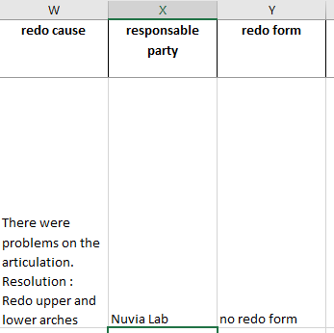

Imagen 1.5: cause, responsable party and form information for the redo cases.

Now I’ll explain the more complex file on this report, named 'Reported sheet_{month}.xlsx' on the folder path ‘. /results/’. The mean goal of this part it´s mesure the performance of the company by región, centers, products, weeks, month and some other important characteristics using insigth on the process for that.

If you open the file you’ll see the named sheet : Report, percents_by_region, Gcam_to_24z, monthly_report, monthly_percents_regions, N6_analysis, database_month_in_and_out, errors. Let´s talk about the first one, Report, on this you can see differents columns

|  |  |
| --- | --- |
| Count of arches | 24Z_Full Mouth , 24Z_Single, G-CAM_Full Mouth G-CAM_Single, N4 arches  N3_redo, N6, N6_redo |
| Number of products and quantities | N_delivery_on_time, N_surgeries, Labtime |
| Count arches on other products | reline_sum, N7_total |
| Count of products | N_delivery_n3_redos_on_time, N_delivery_n6_on_time, N_surgeries_N3, N_surgeries_N6, N_surgeries_other_products Total_arches, N_delivery_on_time_total, N_surgeries_total |
| Percents of products and arches | zirconia , redo_n3, redo_n6, capacity, delivery, reline, surgeries, material_change |
| classification | Region, week_number, center |

Table 1.0 : List of columns on the report sheet by it´s characteristics.

On this section, we don´t want to be so much redundant about the sum of arches and count of products. In general, the columns on the **count of arches**  row on table 1.0 are the sum on the arches by itps material and arch type or by it´s product class and redo type for the redo arches.

On the **N_** columns you will get the count of the products by named characteristics with the **_total**  meaning as the sum of this quantities. On the percents of products and arches I give you the defination of this percents below :

**N4 arches = sum of the total N3 arches**

**Zirconia = sum of the n3 zirconia arches / N4 arches**

**Redo_n3 = sum of n3 redo arches / total arches**

**Redo_n6 = sum of n6 redo arches / total arches**

**Capacity = total arches/capacity of the week**

**Delivery = N_delivery_on_time_total / N_delivery**

**Reline = reline_sum / total arches**

**Surgeries = N_surgeries_N3 / total arches**

**Material_change = N_surgeries_N6 / total arches**

Taking in count that

**total arches = sum of the total N3 and the total of N6 arches.**

Usually the capacity of the week by each center it´s 20 but on some weeks it could be less because it´s taked as 4 arches by day, so that depend on the productive days on the center.

Let´s talk about the second one, the percents_by_region sheet, this have the values of the parameters redo_n3, redo_n6, zirconia, capacity, delivery by region and week_number.

On the Gcam_to_24z sheet, you can find the information of the pmma and gcam arches of the patients which it´s last used material was one of they and theorically they´re waiting for a material change to a zirconia products.This number of arches are classificated by year, month of the delivered arches, center, material and region.

On the monthly_report, as you may imagine, there it´s the same information of the sheet report but in a monthly time lapse. Similarly for the monthly_percents_regions sheet.

As for the N6 analysis you will find a regularly study that count the number of material change arches made by center and region labeled as mc. As for the other columns, there meanings are:

**mc_dummy:** how many of this material change arches becomes dummy arches as it´s next selected product.

**mc_reline:** how many of this material change arches becomes reline arches as it´s next selected product.

**mc_redo:** how many of this material change arches becomes redo arches as it´s next selected product.

In database_month_in_and_out sheet you will find the orders of the report, bases on this information the counts and classification is made. Please see the “create characteristic” report below for a more detailed explanation of the about the meaning of the columns in there.

For the error sheet you need to take in count that this sheet contain the error on the database found where the data cleaning were made. This could by of two type, arch_error or amount_error, please look on the respectice column to filter and study the information. If it´s needed you can contact the platform department on nuvia smiles

# Weekly_waiting_for_24z:

For the second option on the report you just need to update the information and select the month and range of weeks where you want to know the number of pmma arches waiting for 24z material change. This is the weekly counter of the pmma arches waiting for material change on nuvia lab for Alex´s report. On the screen you will see a table with this information, like this:

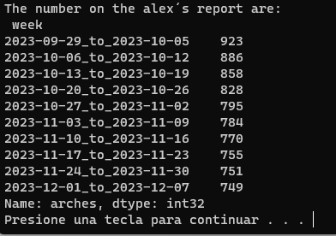

Image 2.0 : Screen of the report number 2, weekly_waiting_for_24z report.

# Restorer_products:

On this report you will get the number of arches and redos arches by restorer/doctor. Also you will get a n6/n3 ratio number and redo percent by each characteristic (year , month, región, center, restorer) as you can see highlighted in red on image 3.0.

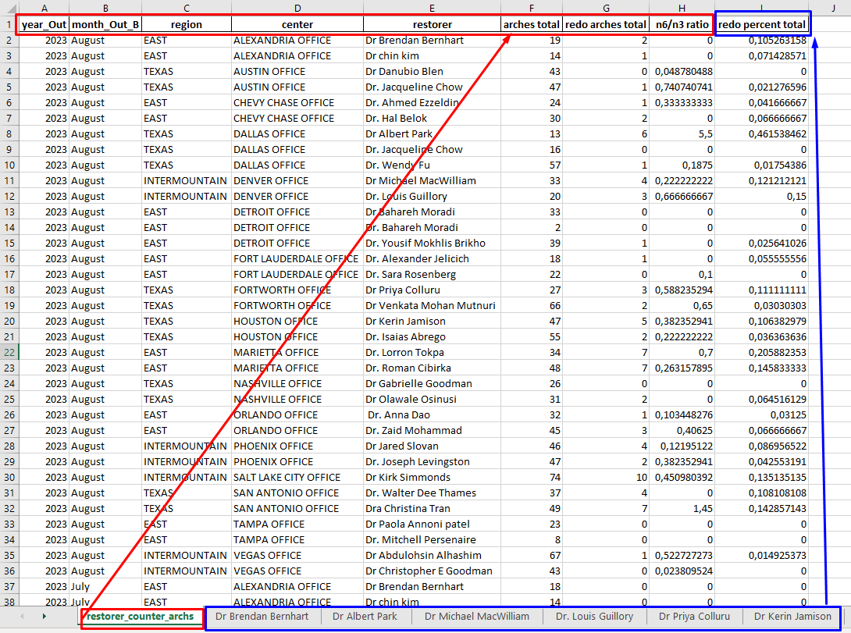

Image 3.0 : visual of the restorer counter arches file on the first sheet.

Finally if if the redo percent total of one restorer it´s higher than 0.1 (10%) the redo cases will get added on it´s sheet labeled by their names as it´s highlighted on blue on imagen 3.1. You should get this information on the path:

***“nuvia_app_reports\results\restorer_counter_archs.xlsx”***

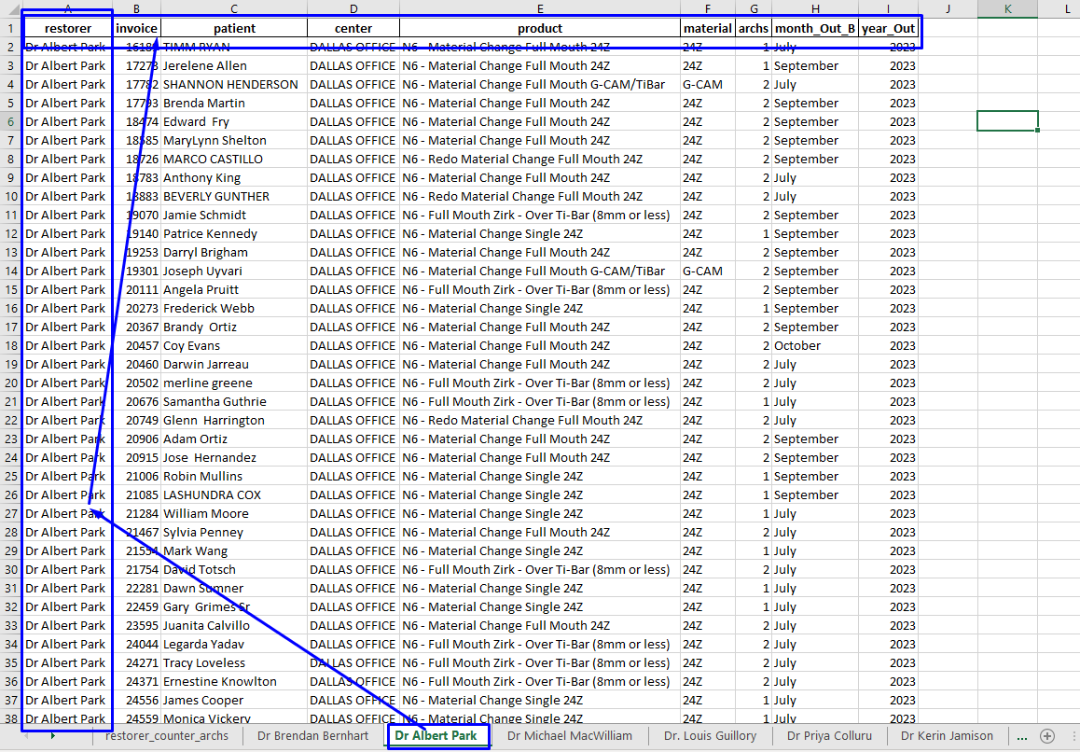

Image 3.1 : Example of one doctor sheet information on the restorer counter arches file.

# Accounting

On this report you will get the information of the arches daily updated by center and weekly_labeled. This information id classificated by arches N3 and redo N3 arches. For the first one you should see the ***“N3 counter”*** and ***“N3 orders”*** sheets. Where you will find the arch counts by : **caterogy_date, center , date_Out** (which it´s date of delivery on nuvialabs platform), those arches are separated on 3 categories : **new 24Z** , **new G-CAM** and **new removable** arches.

The original goal it´s count the arches by material but with the removable arches with fix arches one arch of G-CAM it´s delivery, so for that this column it´s added.

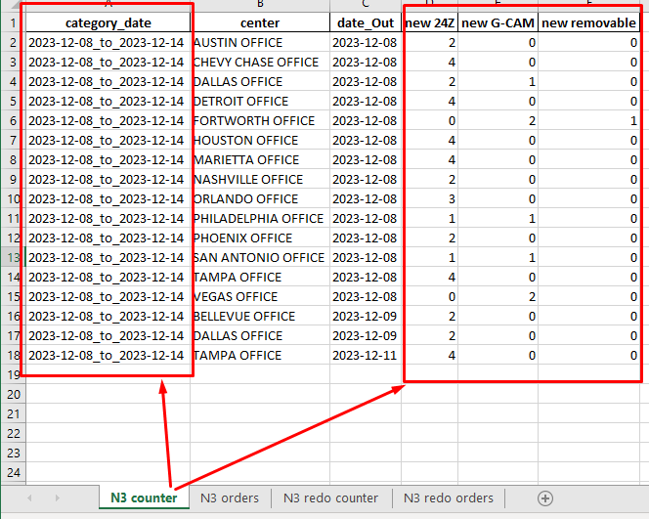

Image 4.0 : N3 counter sheet on accouting report, count of the new arches on nuvia platform.

For the N3 orders there are added the specific orders that are counted on the N3 orders sheet for a more detailed description. As you can see on the image 4.1, there are new columns are added as: **invoice, patient , checkIn , checkOut, product , material, arch type , new 24z and new G-CAM.**

The last two are the check column that inform if that order it´s counted as a new 24z or a new G-CAM arches.

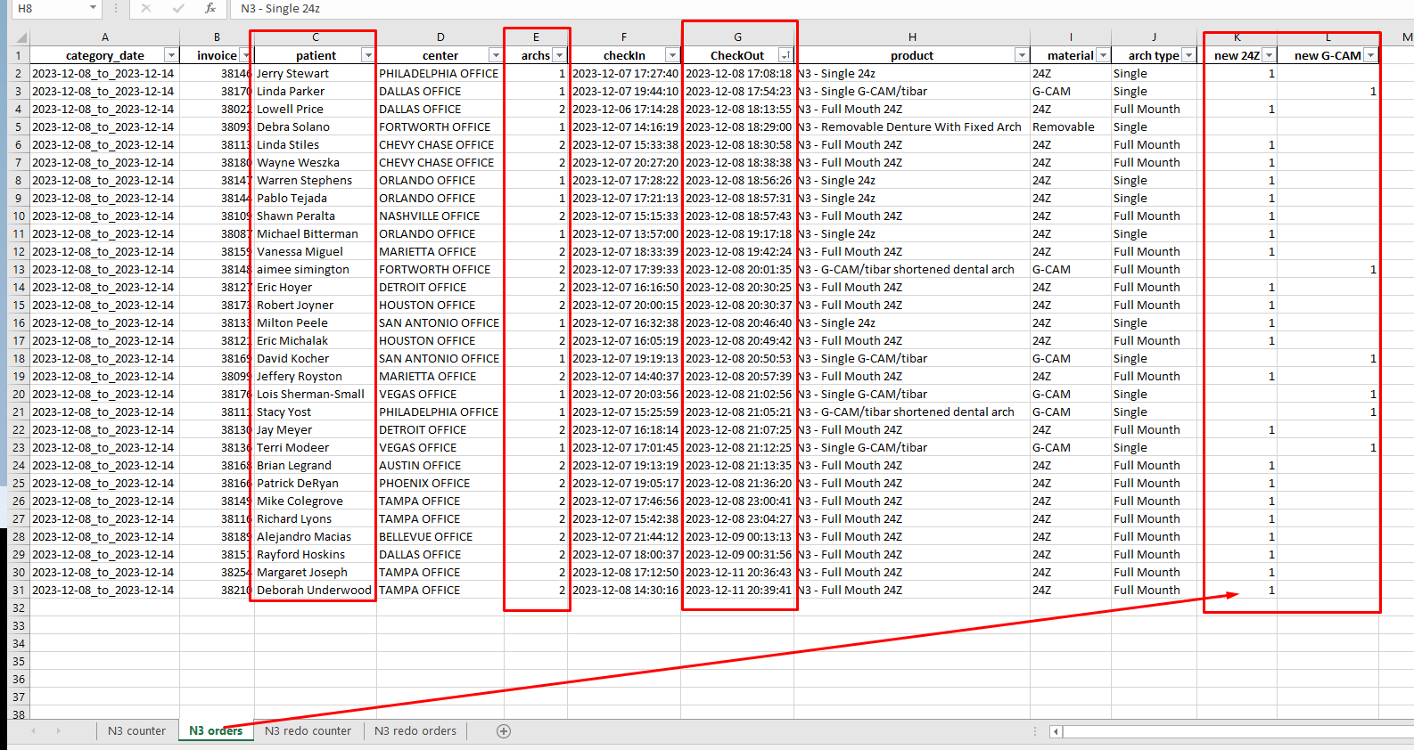

Image 4.1 : N3 orders for the new arches delivered on nuvia platform.

Finally for the count of N3 redo arches we have the ***“N3 redo counter”*** and ***“N3 redo orders”***  sheets where you will get the daily information of the redo arches for the N3 products. On the first sheet, imagen 4.2, it´s shows the redo accouting arch:

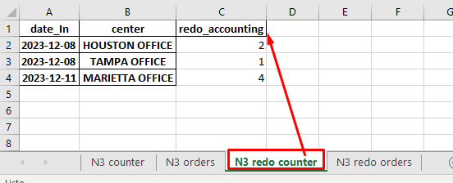

Imagen 4.2: N3 redo counter sheet on accouting report, count of the new created redo arches on nuvia platform.

and the detailed orders on the second sheet as it´s seen on image 4.3:

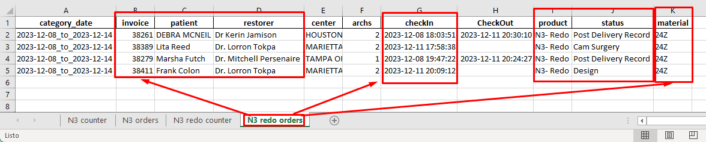Imagen 4.3 : Redo orders for N3 products.

A Collaborative report between the SLC team, regionals, and managers with the Platform data team where the number of new arches is reported. Those are reported on the link below:

<https://docs.google.com/spreadsheets/d/1b0nwSsja8THF2XNR2m7eHwy31JQOooDnN36EO6RXlZ8/edit?usp=sharing>

# Compare_clinic_patients

For this report please update the sheet names and make some checks on the excel file you’ll use to compare this two patients list. Those are : both excel need to have a “patient” column and the clinic excel need to have “Production center” as the name of the offices column.

Then please make sure to take the ***Production+by+center_{MONTH}.xlsx*** file from the clinic and make uploaded on the path ***nuvia_app_reports/data/clinic_data/*** on image 5.0 you have and example.

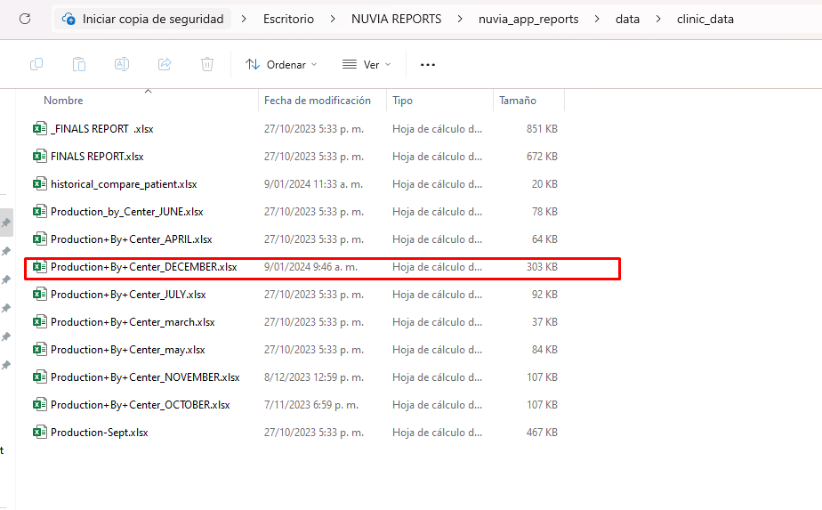

Image 5.0 : clinic_data path and clinic files names.

Now you can ask for a report of those files. For this example we select december 2023 as you may see on image 5.1 below.

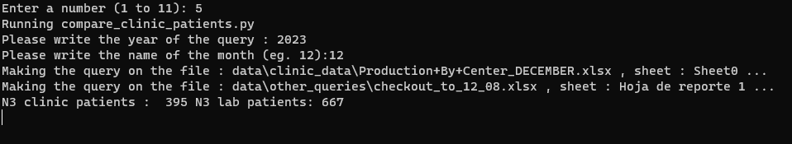

Image 5.1: interface and inputs on the compare patient report, option 5.

This script was created for a comparative beetween the clinic and laboratory data using the patient names as an indexer to merge this data. The goal it´s verify that all the clinic´s patients are on the lab platform. For this propouse we merge this two list of patients but because in some cases for one patient those two names are not equals a new metric that give the percent of similitud are created as you can see on image 5.2.

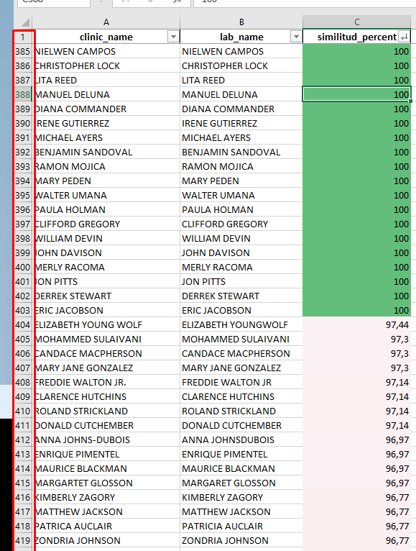

Imagen 5.2: Comparative list of the patients on clinic and lab platforms.

As you can see on the image 5.3 for the first 403 patients the silimitud_percent it´s equal to 100 and the patient it´s correctly choosed. By experience the on the creation of this report, from the data and platform team we saw that a 80% on this similitud_percent column you shouldn´t have problems on the identification of the patients. For the cases lower that than we look for this patient manually making some subjetic variations on the name and taking surgery date, and center´s name as criteria of selection.

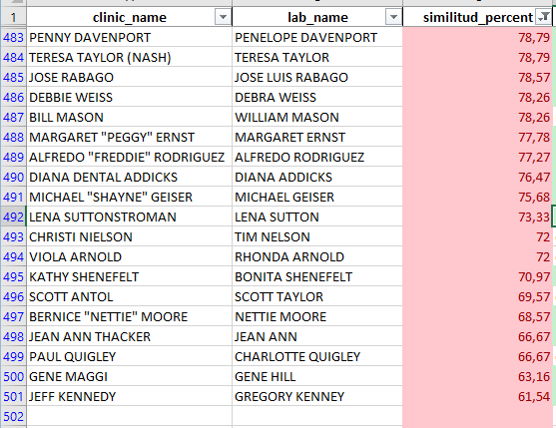

Image 5.2 : list of patients with silimitud_percent lest that 85%.

And it´s not until the patient 483 that we have problem with the selection of the patient. Those cases are manually choosen as we say before.

# Flux_analysis

This a report of the behavior´s arches between one month and another, this quantify how many N3 surgical arches becomes redo arches of different other products on posterior months.

To access at this report make sure to have the updated information for the months you want to study, after you initiate the **“nuvia_app_reports.bat”** file please select the option 6. Later select the year, the months of the start and finish the analysis and the description column that you want to use to describe flux on the arches. If any information it´s empty then the program will select the default values as you can see on the imagen 6.0.

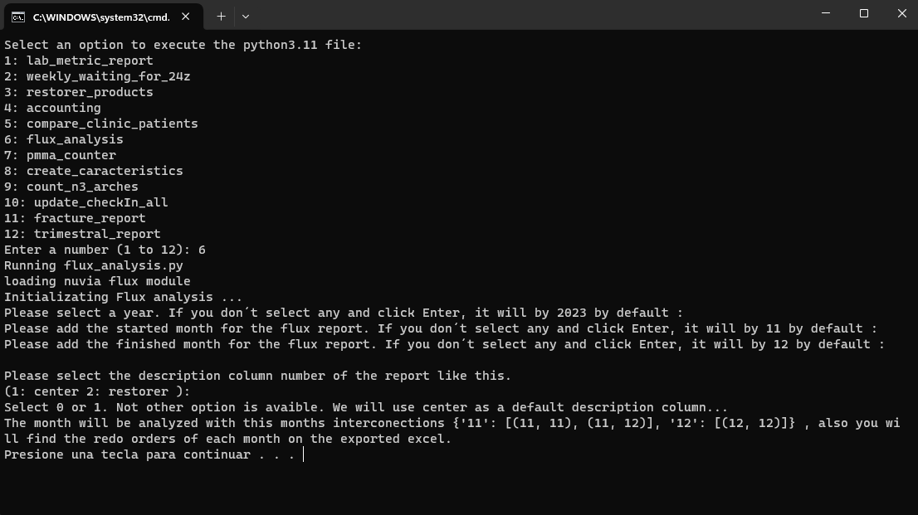

Image 6.0 : Selection and creation of the nuvia Flux report.

The program will start and you will see a empty space, please give it some minutes to count the products and made the relations it needs. Now you should see a message of the analysis that the program made. Now please look for the exported report on the folder ***". \nuvia_app_reports\results\flux_reports".*** As you can see in the image 6.1 it was created 4 diference excels files, two for center and two for restorer, each one for every option avaible on the description column.

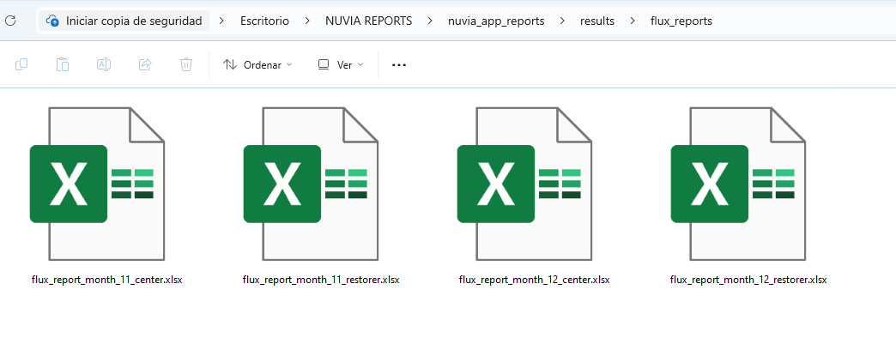

Image 6.1:

Let´s take “flux_report_month_11_center.xlsx” as an example, on image 6.2 you’ll find three different sheets named as : “report, db_nx_patient, redos_month”. On the first one there will be a table with the number of arches by center and some characteristics that it’ll be described below by sections.

**Section 1:** Here are the center’s names, number of N3 product´s arches and how many was made on G-CAM material.

**Section 2:** Here are the redo arches of the month by center and how many of then were taken as clinic on the responsability party part.

**Section 3:** Here are the N3 arches that becomes diferents products as redos, remake, dummy, reline, material change or to weeks records on the history of the patient. This change on the product could happen on the same month or on another one. For that, the section 4 was created.

**Section 4:** Here are the month where the surgery was made in the column named **month start** and the month where the change of the product was made in the column named **month end**.

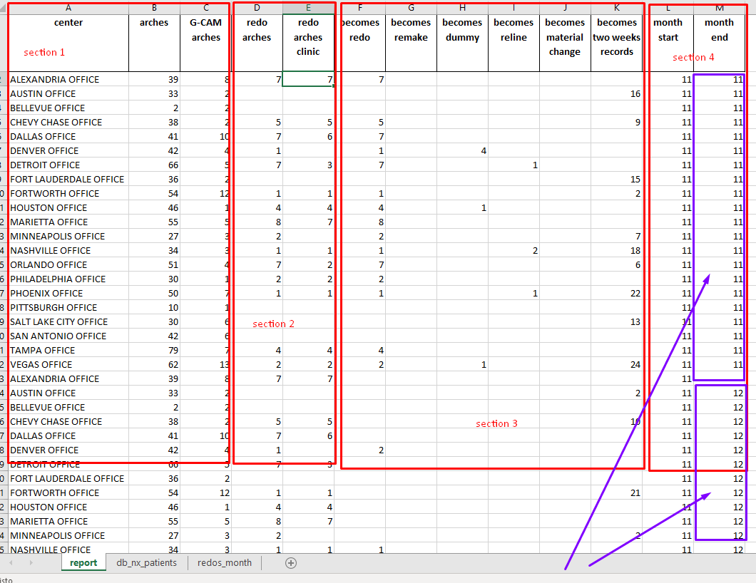

Image 6.2 : flux report of the arches from n3 product to other products.

Finally the **db_nx_patient** and the **redos_month** sheets have the orders of all the products that are counted on the report and the redo arches that belong to the month of the report.

As for the other 3 excels files exported on the flux_report folder (image 6.1) they have a similar structure, taking in count that the filex with the name **_restorer** on they names have an analysis by restorer, and the logical of the report it based on the combinations of the month start and it´s different futures months end. That it´s for 11 it’ll be 11 and 12 but from 12 it should be only 12 for the year 2023.

# Pmma_counter

A report of the number of arches made on PMMA waiting for a material change on 24Z. Please look for the excel file on the path :

***".\ nuvia_app_reports\results\waiting_for_24z.xlsx"***

On this document you can find a list of sheet that will be explained bellow. The first one it´s named ‘pmma_cases_waiting_’ you will find 3 differents group of columns as we shown on the image 7.0. With the red box you can find the year and month for the creation of the order with the pmma arches. With the green box it´showed the center, sum of arches and material, for this last one it has two values : PMMA and G-CAM as the possible materials that are used on this type of products. On the other hand, in the blue box you will find the month an the year of medition of this quantities, note that this it´s different from the month and year of the creation of the products, this columns on the blue box are the period of time when it was counted the quantity of this type of arches by center and materials.

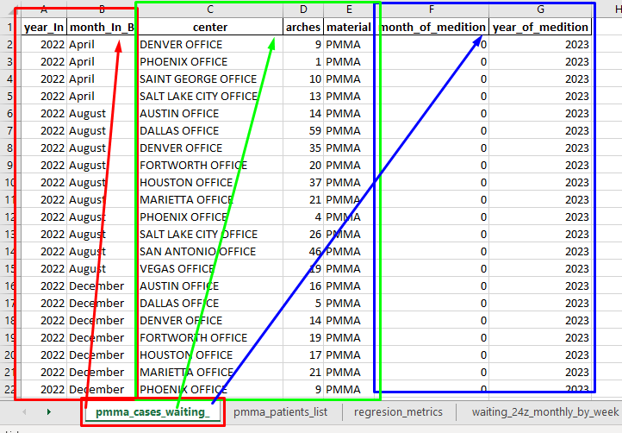

Image 7.0 : pmma_cases_waiting_ sheet on the pmma_counter report.

On the ‘pmma_patients_list’ are the orders of the patients waiting for 24z material change with different categories as :

|  |  |  |  |  |  |  |  |
| --- | --- | --- | --- | --- | --- | --- | --- |
| **invoice** | **patient** | **restorer** | **center** | **archs** | **checkIn** | **CheckOut** | **amount** |
| **product** | **month_In** | **month_Out** | **diff_days** | **region** | **product class** | **material** | **arch type** |
| **redo type** | **diff_hour** | **delivery_on_time** | **month_In_B** | **year_In** | **month_Out_B** | **year_Out** |  |

Table 7.1 : Columns on ***waiting_for_24z.xlsx*** file on the sheet ***pmma_patients_list.***

For the three sheet labeled as “regresion_metrics”

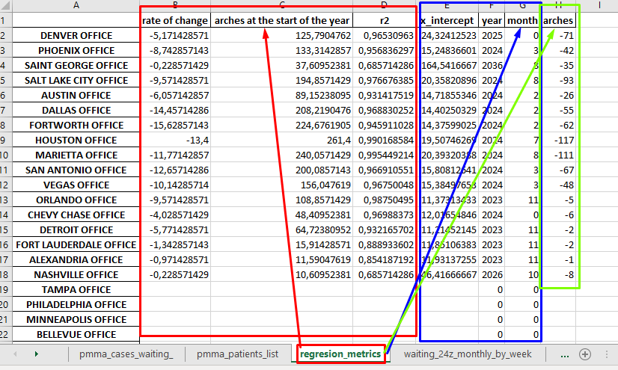

Image 7.2 : Linear regresions of the pmma decrease by center. Regresion_metrics sheet of the excel file.

The first group of columns in red boxes are the linear regresion coeficients and r2 values. The meaning of this are describe here :

* **Rate_of_change**: Those are the rate of change on the pmma arches for the selected time interval of the report.
* **Arches at the start of the year**: Those are the intercept of the linear regresions by each center, those are the prediction of this quantity by the lineal model.
* **R2**: This value is a metric of the currency of the model. This could by beetween 0 and 1, the more near to 1, the more the model it´s correct.

For the second group of blue box of columns a extrapolation it´s given on the **x_intercept**. That is, the number of the month when the pmma arches should be finished taking in count the rate of change of each center. The decimal values are converted on the **year** and **month** columns.

Finally in the green box there is a **arches** column with negative values on it. This are the rate ideal rate of change of this pmma arches that the centers should have if the want to finished this type of material change by a selected date. For this example it´s choosed the end of the year 2023.

There are a four sheet named “waiting_24z_monthly_by_week”. Here you can find the quantities

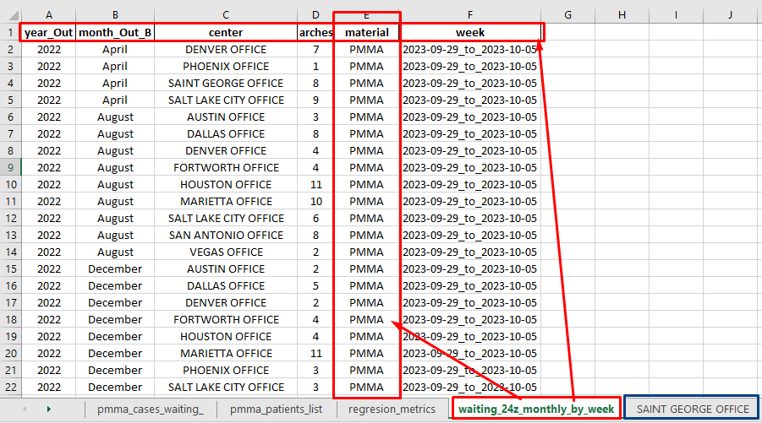

Imagen 7.3 : number of arches on pmma and gcam waiting for material change, classified by year, month of delivery, center, material and reported week.

On the other sheets you will find the orders of this PMMA arches by center, for example, on the blue box it´s highlighted ***SAINT GEORGE OFFICE*** there you fill find the columns :

|  |  |  |  |  |
| --- | --- | --- | --- | --- |
| **patient** | **center** | **archs** | **date_Out** | **arch type** |

# Create_caracteristics

This report it was created for the caracterization and classification of the arches on Nuvia´s enterprise. For this propouse different characteristics are created on diferrents columns on the orders information sheet.

From a start, please see for the method to extract the information of the orders on nuvialabs.com/reports from the financial section on the documentation of this app, look for it on the path ***". \documentation\Nuvia app report english.pdf"***

On the excel file that you export you will find a sheet with the named columns seen on the Table 8.0 for each order on the month of you selection:

|  |  |  |  |  |
| --- | --- | --- | --- | --- |
| invoice | patient | restorer | center | archs |
| checkIn | CheckOut | Due | amount | product |
| doctor_comment | warranty | warranty_comments | status |  |

Tabla 8.0 : Exported information extracted from the financial reports on check in and check out sections.

If you want to create different classifications on this orders please update the month of you selection as you could see in the “***Nuvia app report english.pdf”***  document. Then please open the ***nuvia_app_report.bat*** , making doble click to this file an terminal windowns will appear, for this report you will select the number 8 as you can see in the imagen 8.0.

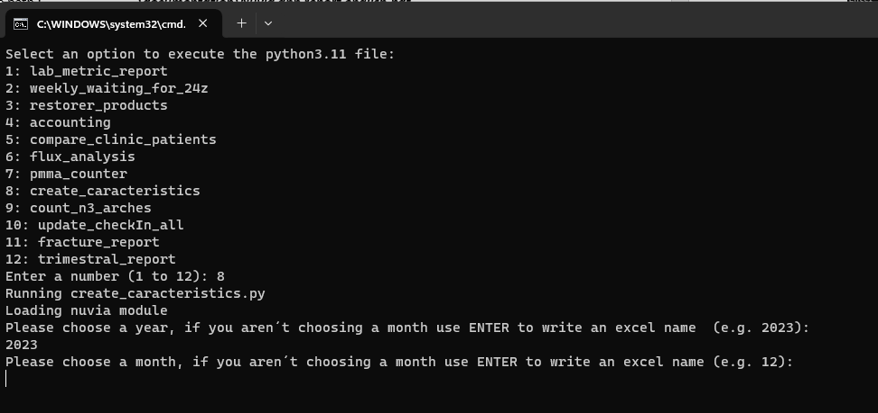

Image 8.0 : Use of the create_caracteristic option on the reports.

There you will see a message that ask you a year and month selection, you have the option to select this values: 2022 , 2023 or 2024 for a year and the 1 to 12 for a month, where 1 is january and 12 is december. Taking as example the year, month equal to 2023, 12 please look for the excel file on the folder with the path (image 8.1) ***".\nuvia_app_reports\data\2023\12"***.

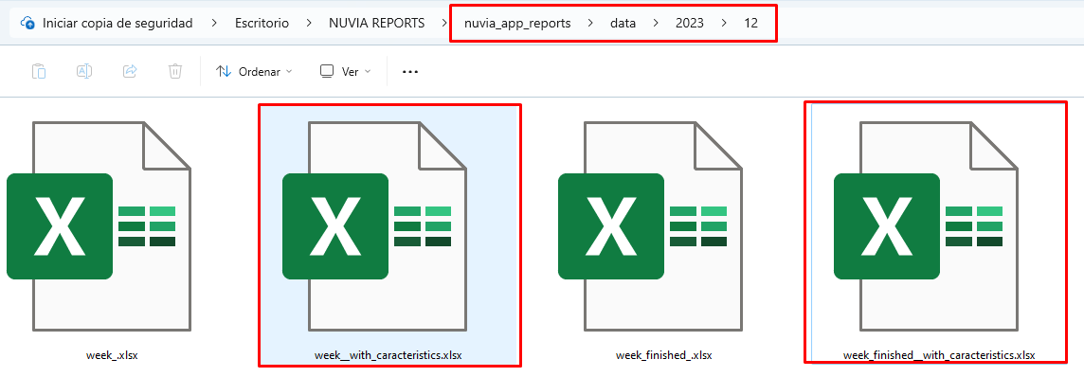

Image 8.2: excel fields on the folder ***data/{year}/{month}.***

As you can see on imagen 8.1 on this folder you will find the ***week_.xlsx*** and ***week_finished_.xlsx*** files, this are the fields exported from nuvia´s platform. The other ones labeled as ***“*_with_caracteristics.xlsx”*** are the fields with the new columns added that are described by groups on the table 8.1 below.

|  |  |
| --- | --- |
| ***classification*** | ***columns names*** |
| orders information | Invoice , patient, restorer, center, region |
| creation of the orders information | checkIn, date_In, month_In, time_in, hour_in, month_in_B, year_In |
| finalization of the orders information | checkOut, date_Out, month_Out, time_out, hour_out, month_Out_B, year_Out |
| characteristics of the orders | product, archs, amount, status |
| properties of the products | product_class, material, arch type, redo type |
| different times of the orders | diff_days, diff_hour, delivery_on_time |

Table 8.1 : information of the sheets with caracteristics.

Also there is an option to let the input empty, if you do that please select an excel file path without the extension (.xlsx) to create and export the characteristics from this file, this will be exported on the same folder of the file you are choosen.

# Inventory_report

For this report we create a count of the arches of the month by different characteristics, this report it from the 9 selection on ***nuvia_app_report***  as it´s seen on the image 9.0.

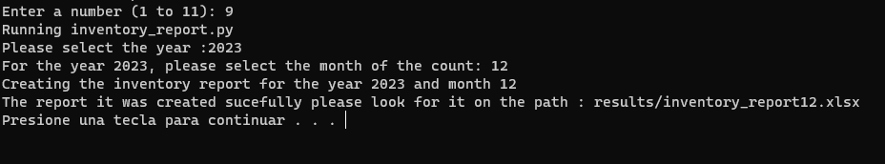

Image 9.0 : nuvia app report selection 9 interface with the user.

Once you find and open the excel file you will find 6 sheet named arches, redos, arch_type, material, shape with the arches and it´s differents characteristics, the last sheet named orders have the order of the month where the arches are counted. Here on image 9.1 are a short view of this tables format.

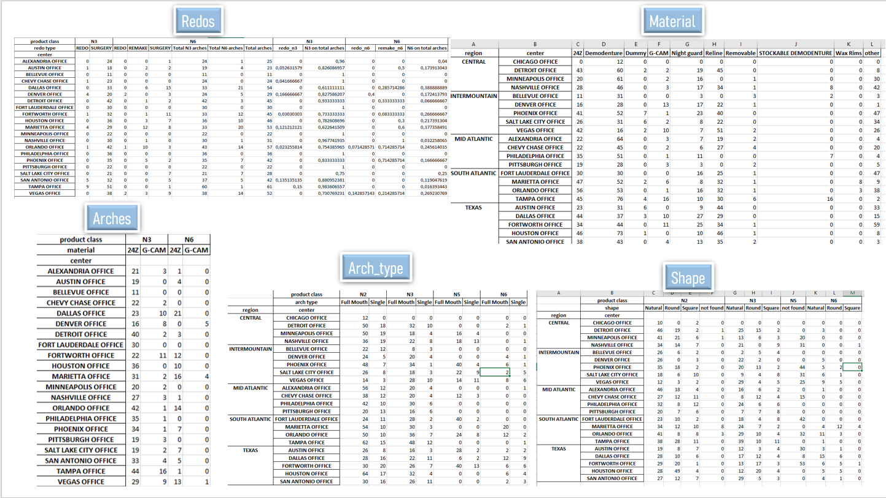

Image 9.1 : short view of the format´s sheet on inventory report.

For the redo report it´s needed to explain how the percents are calculate, as we write below :

* **Totals, Total N3 arches :** (N3, REDO) + (N3, SURGERY)
* **Totals, Total N6 arches :** N6, REDO) + (N6, REMAKE) + (N6, SURGERY)
* **Totals, total arches :** (Totals, Total N3 arches) + (Totals, Total N6 arches)
* **N3, redo_n3 :**  (N3, REDO) / (Totals, Totals N3 arches)
* **N3, N3 on total arches:** (Totals, Total N3 arches) / (Totals, Total arches)
* **N6, redo_n6 :**  (N6, REDO) / (Totals, Totals N6 arches)
* **N6, remake_n6 :**  (N6, REDO) / (Totals, Totals N6 arches)
* **N6, N6 on total arches:** (Totals, Total N6 arches) / (Totals, Total arches)

# Update_checkIn_all

On this option you can update the ***nuvia_app_report/data/checkIn_all.xlsx*** file where all the created orders are saved. As you can see on image 10.0, the method ask you for the month of creation of the orders you want to add on this file. This is important for the analysis on N6 products and pmma arches. This must be done each month for correct calculations on the quantities and properties in the nuvia_app_report system. Please take in count that the system need to read all created orders, so it could be a late process.

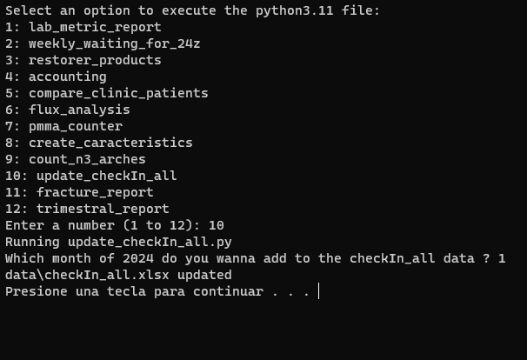

Image 10.0 : Method number 10, update_checkIn_all file.

# Fracture_report

A report of the fractured arches detected on Nuvia smiles. On this report you can find the count and description of this fractures. In image 11.0 you will see the diferent sheets that are exported for this report. On the first box, highlighted on red, are the list of orders from the fracture database and platform database.



Image 11.0 : sheets on results/data_fracture.xlsx file.

For the second box in the middle, you can find the description of the the fractures by centers, in **“resume”** a general count of this, in **“resume_for_percents”** and **“percents”** you will find this count by center and other characteristics as you can see on image 11.1

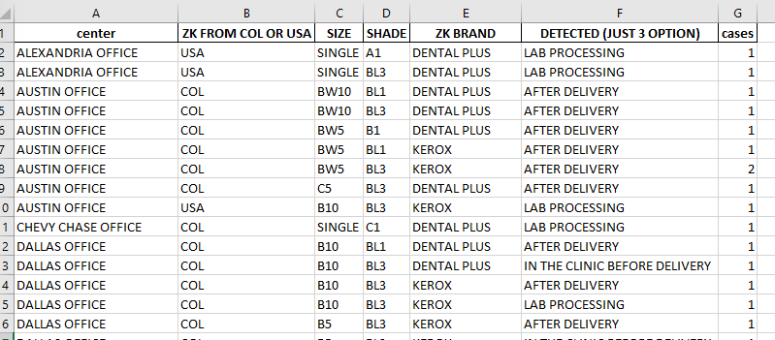

Image 11.1 : resume_for_percents sheet on fracture report file.

On the percents, imagen 11.2, you will get the percent of this cases by each one of this parameters. Also on the third box, you find the same counter of cases by year and months.

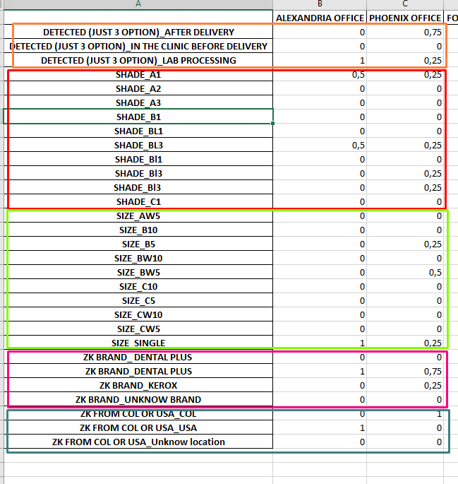

Imagen 11.2 : percents sheet on the fracture report classifided by center.